Glory Be
Glory be to the Father, and to the Son, and to the Holy Spirit.
As it was in the beginning is now, and ever shall be, world without end.
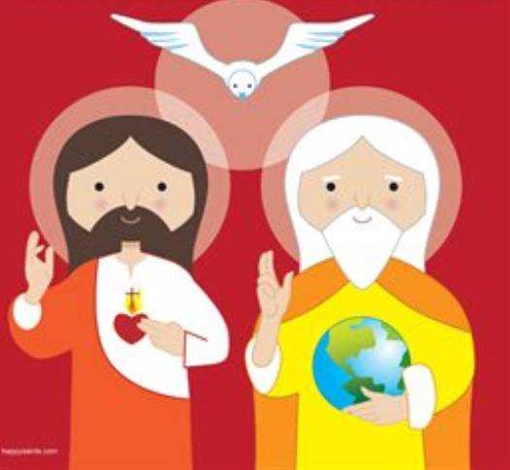
Amen.

