**Year 3 /4 Recommended Reading List**

Here is a list of some of our favourite books for your child to read at home.

Happy reading!

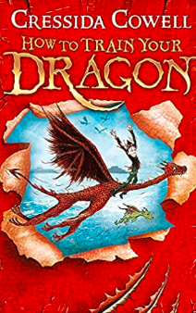

How to Train Your Dragon – Cressida Cowell

Hiccup Horrendous Haddock the Third is a smallish Viking with a longish name. Hiccup's father is chief of the Hairy Hooligan tribe which means Hiccup is the Hope and the Heir to the Hairy Hooligan throne - but most of the time Hiccup feels like a very ordinary boy, finding it hard to be a Hero.

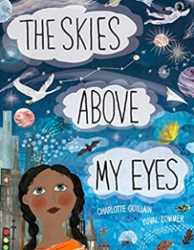

The Skies Above My Eyes – Cressida Cowell

Have you ever looked up and wondered what's going on high up in the skies above your eyes? Take a journey up into the air, through the atmosphere, way out into space and back down to Earth in this richly illustrated concertina book.

The Butterfly Lion – Michael Morpurgo

Bertie rescues an orphaned white lion cub from the African veld. They are inseparable until Bertie is sent to boarding school far away in England and the lion is sold to a circus. Will they see each other again?

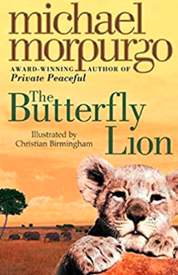

How to Help Hedgehog and Protect a Polar Bear– Jess French

Learn how you can save endangered animals and make the world a better place, too! From beetles and butterflies, to puffins and polar bears, animals and habitats all over the world need our protection. In this beautifully illustrated book, children (and adults!) can learn everyday ways to protect them.

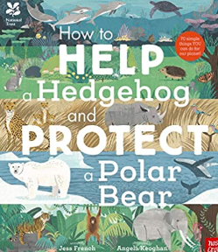

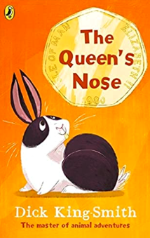

The Queen’s Nose – Dick King-Smith

Harmony's uncle sends her on a treasure trail - which disappointingly ends in her finding a 50p piece. But the coin is a magic one, and when you rub the queen's nose, your wishes will come true! From the number one author for animal magic comes this wonderful new edition of a much-loved classic.



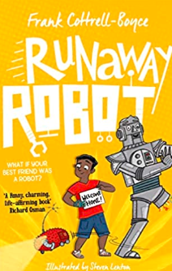

Runaway Robot – Frank Crottrell Boyce

When Alfie goes to Airport Lost Property, he finds more than he bargained for. A lot more. Because there's a giant robot called Eric hidden away on the shelves. Eric has lost one leg and half his memory. He's super strong, but super clumsy. He's convinced that he's the latest technology, when he's actually nearly one hundred year's old and ready for the scrap heap.

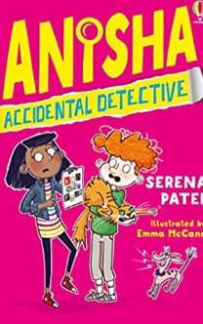

Anisha – Accidental Dectective

Anisha is all set to be a (reluctant) bridesmaid at Aunty Bindi's wedding...until a secret ransom note arrives. Bindi's groom has been kidnapped and will only be released if the wedding is called off! It's up to Anisha Mistry to find her uncle, before the big family wedding of the year becomes a big disaster.

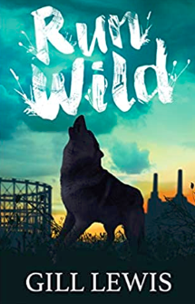

Run Wild – Gill Lewis

Izzy and Asha need a space to call their own, away from difficult families, the Skull brothers and the trouble they bring. But the derelict building site where they stake their claim already belongs to something else, a wilderness they never expected and an injured wolf that desperately needs their help.

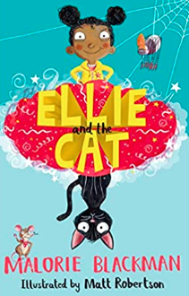

Ellie and the Cat – Malorie Blackman

Ellie is the rudest, most spoilt child her grandma has ever met and it's time that she learnt a lesson! So with a little bit of magic and some help from Jolly the cat, Grandma's going to make sure that Ellie changes her ways.

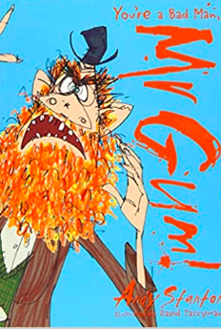

Mr Gum – Andy Stanton

Shabba me whiskers! It’s that bestselling and award-winning first ever Mr Gum book by Andy Stanton. The Mr Gum books are only the craziest, funniest most best books for children in the whole wide world.



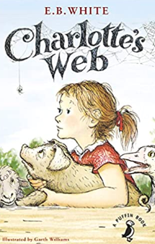

Charlotte’s Web – E.B. White

Wilbur the pig's life has already been saved by Fern, but when he is sold to her uncle, he realises his life is in even more danger. Enter Charlotte, a beautiful large grey spider. Charlotte is determined to keep Wilbur from the chopping block, and comes up with an ingenious way to do just that.

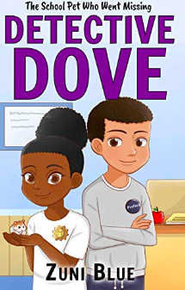

Dective Dove – Zuni Blue

Mya loves solving mysteries! Her latest case is about Malcolm, the school hamster. He’s friendly, smart and…missing! That’s why Mya needs help finding him. When she asks for backup, her classmates are helpful. The teachers aren’t. Do they know where Malcolm is?

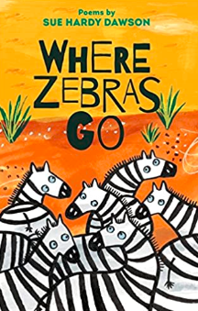

Where Zebra’s Go

Get ready to join in the Poetry Olympics, question a snake, talk to a toad and learn 20 ways to avoid monsters and mythical beasts. This is a diverse and exciting debut collection by a poets who performs regularly in schools across the country.

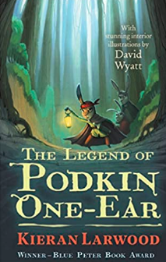

The Legend of Podkin One-Ear – Kieran Larwood

Podkin is the son of a warrior chieftain. He knows that one day it will be up to him to lead his warren and guard it in times of danger. But for now, he's quite happy to laze around. Then Podkin's home is brutally attacked, and the young rabbits are forced to flee.

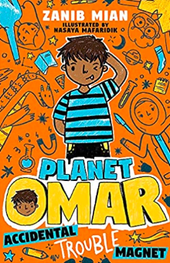

Planet Omar – Zanib Mian

Welcome, readers, to the imaginative brain of Omar! You might not know me yet, but once you open the pages of this book you'll laugh so hard that snot will come out of your nose (plus you might meet a dragon and a zombie - what more could you want?)



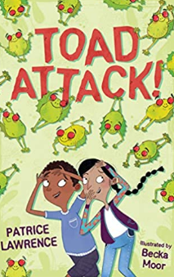

Toad Attack – Patrice Lawrence

After a toad lands on his head as he leaves his house one morning, Leo is determined to find out where it has come from and why. Together with his friend Rosa, he needs to come up with some answers before the angry residents of Upper Dab take matters into their own hands and the toads become toast!

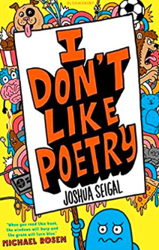

I Don’t Like Poetry – Joshua Seigal

Packed full of silly, funny, or downright hilarious poems (with a few serious ones mixed in) this brilliant collection from exciting young poet, Joshua Seigal is perfect for fans of Michael Rosen and anyone else who needs a giggle. If you like poetry, you'll like this book. And if you don't like poetry you'll LOVE it!

The Demon Headmaster – Gillian Cross

When Dinah is fostered by the Hunters she thinks her biggest problem will be fitting in with her foster-brothers, Lloyd and Harvey. However, once she starts at her new school it's clear that there's more to worry about. All the children, apart from a handful are too well-behaved - robotic almost - and oddly keen to please the creepy headmaster.

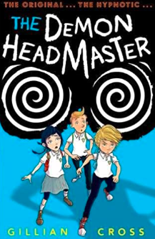

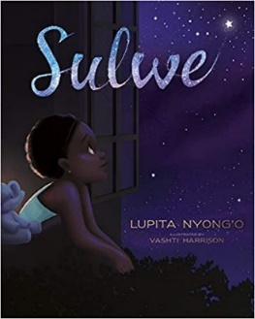

Sulwe – [Lupita Nyong'o](https://www.amazon.co.uk/s/ref=dp_byline_sr_book_1?ie=UTF8&field-author=Lupita+Nyong%27o&text=Lupita+Nyong%27o&sort=relevancerank&search-alias=books-uk)

Sulwe's skin is the colour of midnight. She's darker than everyone in her family, and everyone at school. All she wants is to be beautiful and bright, like her mother and sister. Then a magical journey through the night sky opens her eyes and changes everything.

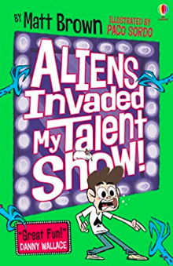

Aliens Invaded my Talent Show – Matt Brown

Eric Doomsday loves doing magic tricks, even though they always end up going very wrong, so he's determined to get it right for the Dreary Inkling school talent show. But when the talent-show judges reveal themselves to be hideous aliens who want to destroy the world, the fate of the planet rests on one boy.



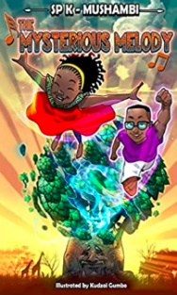

The mysterious melody – SPK Mushambi

Twins Naniso and Shinga live in England. They find each other annoying, but when it comes to the crunch, they always have each other's back. When they are both awakened in the early hours of the morning by a mysterious melody, they join forces to find the source.

Real – life mysteries – Susan Martineau

Have you ever wondered what exactly does go bump in the night? From mysteries like Shackleton's ghostly companion to the Loch Ness Monster and friends, read the amazing evidence about these mysterious cases and make up your own mind. Quench your curiosity with this new myth-busting (and sometimes, myth-confirming!) fascinating kids case study book.

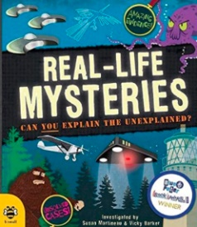

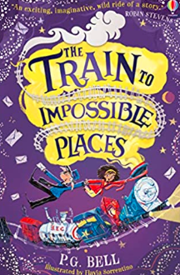

The Train to Impossible Places – P.G. Bell

When Suzy hears a strange noise in the middle of the night, she creeps downstairs to find a train roaring through her house. But this is no ordinary train. This is the magical delivery express for the Union of Impossible Places.

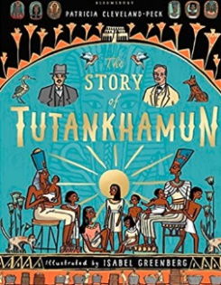

The Story of Tutankhamun – Patricia Cleveland- Peck

Uncover the true story of an Egyptian king, and the 20th century explorer who found him. Discover the troubles Tutankhamun faced as a young king, his untimely death, and his legacy, which lay hidden for centuries. Pore over his treasures, learn the steps of mummification, and see Tutankhamun's fascinating story bought to life.

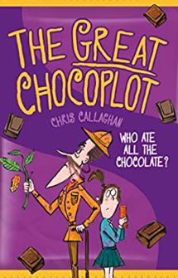

The Great Chocoplot – Chris Callaghan

Jelly and her family live in Chompton-on-de-Lyte, where everyone loves a Chocablocka bar or two. So when the end of chocolate is announced, she can't believe it. Determined to investigate, Jelly and her gran follow a trail of clues to a posh chocolate shop and its owner, the pompous Garibaldi Chocolati.



   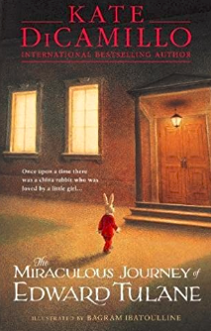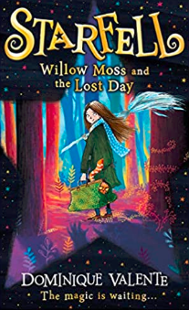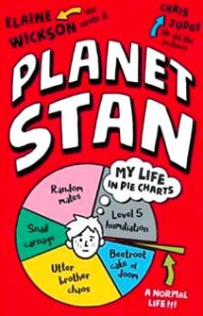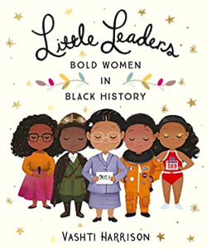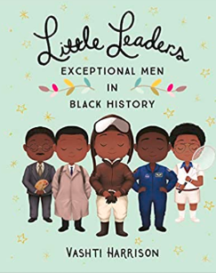

The Miraculous Journey of Edward Tulane – Katie Dicamilla

Abilene loves her blue china rabbit, but Edward Tulane is extremely vain and only loves himself. On a voyage from New York to London, Edward falls overboard and from there finds himself on an amazing journey. He travels with tramps, works as a scarecrow, comforts a dying child ... and finally learns what it is to truly love.

Starfell: Willow Moss and the Lost Days – Dominique Valente

Find out some famous black women including: Nurse Mary Seacole, Politician Diane Abbott, Mathematician Katherine Johnson and Singer Shirley Bassey. Inspire your own little leader with the stories of these amazing women.

Planet Stan – Elaine Wickson

Stan loves everything to do with space, along with a calming, ordered environment, pie charts, and Venn diagrams. His dinosaur-loving younger brother Fred is the opposite. Surely they must have something in common? Find out through a series of hilarious infographics in this highly-illustrated and visually-appealing book.

Bold Women in Black History – Vashti Harrison

Find out some famous black women including: Nurse Mary Seacole, Politician Diane Abbott, Mathematician Katherine Johnson and Singer Shirley Bassey. Inspire your own little leader with the stories of these amazing women.

Exceptional Men in Black History – Vashti Harrison

Learn all about the exceptional black men who broke barriers and fought injustice to realise their dreams and make the world a better place for example: Doctor Harold Moody, Diplomat Kofi Annan, Activist Paul Stephenson, Architect Sir David Adjaye, Comic book author Dwayne McDuffie and Musician Prince.