The Angelus
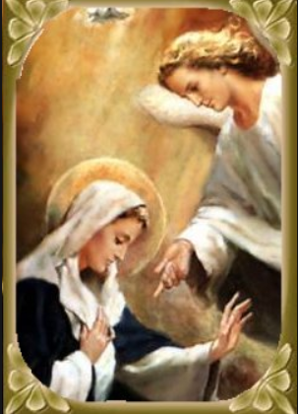
V. The Angel of the Lord declared unto Mary,
R. And she conceived of the Holy Spirit.
Hail Mary, full of grace…
V. Behold the handmaid of the Lord.
R. Be it done unto me according to Your Word.
Hail Mary, full of grace…
V. And the Word was made flesh,
R. And dwelt among us.
Hail Mary, full of grace…
V. Pray for us, O holy Mother of God.
R. That we may be made worthy of the promises of Christ.
Let us pray:
Pour forth, we beseech You, O Lord,
Your Grace into our hearts;
that as we have known the incarnation of Christ,
your Son by the message of an angel,
so by His passion and cross
we may be brought to the glory of His Resurrection.
Through the same Christ, our Lord.
Amen.

